1150080065-Nguyễn Quang Mẫn
LAB 2
Bước 1: Tạo trang chủ để liên kết các trang
Trang chủ
AndroidManifest.xml
<?xml version="1.0" encoding="utf-8"?>
<manifest xmlns:android="http://schemas.android.com/apk/res/android">
<application
android:allowBackup="true"
android:icon="@mipmap/ic_launcher"
android:label="@string/app_name"
android:supportsRtl="true"
android:theme="@style/Theme.AppCompat.Light.NoActionBar">
<activity android:name=".Bai3Activity" android:exported="true" />
<activity android:name=".Bai2Activity" android:exported="true" />
<activity android:name=".Bai1Activity" android:exported="true" />
<activity
android:name=".MainActivity"
android:exported="true">
<intent-filter>
<action android:name="android.intent.action.MAIN" />
<category android:name="android.intent.category.LAUNCHER" />
</intent-filter>
</activity>
</application>
</manifest>
MainActivity.java
package com.example.uidesign;
import android.content.Intent;
import android.os.Bundle;
import android.widget.Button;
import androidx.appcompat.app.AppCompatActivity;
public class MainActivity extends AppCompatActivity {
@Override
protected void onCreate(Bundle savedInstanceState) {
super.onCreate(savedInstanceState);
setContentView(R.layout.activity_main);
Button btn1 = findViewById(R.id.btnBai1);
Button btn2 = findViewById(R.id.btnBai2);
Button btn3 = findViewById(R.id.btnBai3);
btn1.setOnClickListener(v -> startActivity(new Intent(this, Bai1Activity.class)));
btn2.setOnClickListener(v -> startActivity(new Intent(this, Bai2Activity.class)));
btn3.setOnClickListener(v -> startActivity(new Intent(this, Bai3Activity.class)));
}
}
activity_main.xml
<LinearLayout xmlns:android="http://schemas.android.com/apk/res/android"
android:layout_width="match_parent"
android:layout_height="match_parent"
android:gravity="center"
android:orientation="vertical"
android:padding="24dp">
<TextView
android:layout_width="wrap_content"
android:layout_height="wrap_content"
android:text="Nguyễn Quang Mẫn"/>
<Button
android:id="@+id/btnBai1"
android:layout_width="match_parent"
android:layout_height="wrap_content"
android:text="Bài 1: Màu nền và Icon ngẫu nhiên" />
<Button
android:id="@+id/btnBai2"
android:layout_width="match_parent"
android:layout_height="wrap_content"
android:text="Bài 2: Trang Loangding"
android:layout_marginTop="16dp"/>
<Button
android:id="@+id/btnBai3"
android:layout_width="match_parent"
android:layout_height="wrap_content"
android:text="Bài 3: Gọi điện Intent"
android:layout_marginTop="16dp"/>
</LinearLayout>
Kết quả
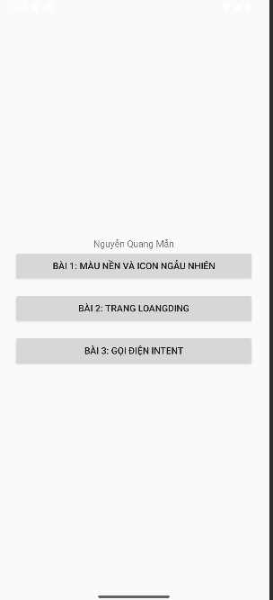
Bài 1:
Bai1Activity.java
package com.example.uidesign;
import android.os.Bundle;
import android.widget.ImageView;
import android.widget.LinearLayout;
import androidx.appcompat.app.AppCompatActivity;
import java.util.Random;
public class Bai1Activity extends AppCompatActivity {
int[] colors = {
0xFFFFCDD2, 0xFFC8E6C9, 0xFFBBDEFB, 0xFFFFF9C4, 0xFFD1C4E9
};
int[] icons = {
R.drawable.img_1,
R.drawable.img_3,
R.drawable.img_4,
R.drawable.favourite,
R.drawable.img
};
@Override
protected void onCreate(Bundle savedInstanceState) {
super.onCreate(savedInstanceState);
setContentView(R.layout.activity_bai1);
LinearLayout layout = findViewById(R.id.layoutBai1);
ImageView imageView = findViewById(R.id.random_icon);
Random random = new Random();
int color = colors[random.nextInt(colors.length)];
int icon = icons[random.nextInt(icons.length)];
layout.setBackgroundColor(color);
imageView.setImageResource(icon);
}
}
actitivity_bai1.xml
<LinearLayout xmlns:android="http://schemas.android.com/apk/res/android"
android:id="@+id/layoutBai1"
android:layout_width="match_parent"
android:layout_height="match_parent"
android:gravity="center"
android:orientation="vertical">
<TextView
android:layout_width="wrap_content"
android:layout_height="wrap_content"
android:text="Nguyễn Quang Mẫn"/>
<ImageView
android:id="@+id/random_icon"
android:layout_width="150dp"
android:layout_height="150dp"
android:contentDescription="random icon" />
</LinearLayout>
Kết quả
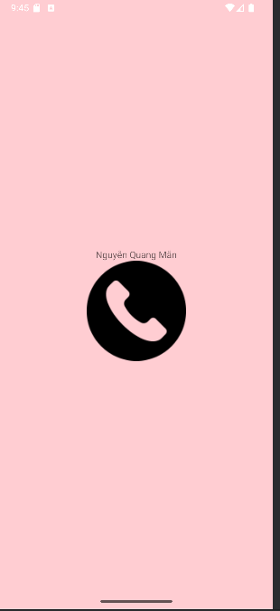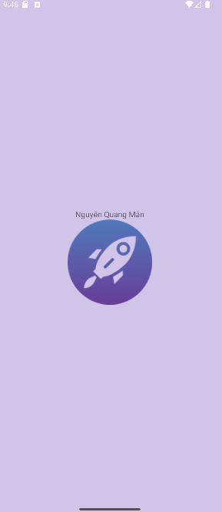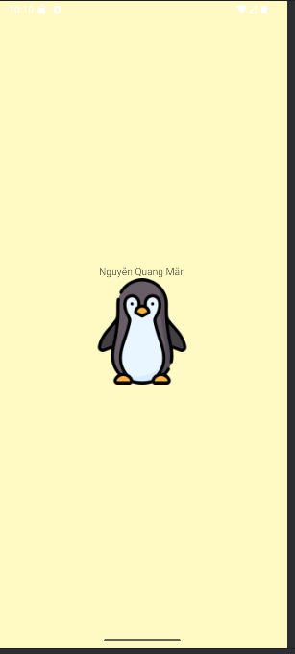
Bài 2
Bai2Activity.java
package com.example.uidesign;
import android.os.Bundle;
import androidx.appcompat.app.AppCompatActivity;
public class Bai2Activity extends AppCompatActivity {
@Override
protected void onCreate(Bundle savedInstanceState) {
super.onCreate(savedInstanceState);
setContentView(R.layout.activity_bai2);
}
}
activity_bai2.xml
<LinearLayout xmlns:android="http://schemas.android.com/apk/res/android"
android:layout_width="match_parent"
android:layout_height="match_parent"
android:gravity="center"
android:orientation="vertical"
android:background="#222">
<ProgressBar
android:layout_width="100dp"
android:layout_height="100dp"
android:indeterminate="true"
android:indeterminateDrawable="@drawable/custom_progress" />
<TextView
android:layout_width="wrap_content"
android:layout_height="wrap_content"
android:text="Đang tải..."
android:textColor="@android:color/white"
android:layout_marginTop="16dp"/>
<TextView
android:layout_width="wrap_content"
android:layout_height="wrap_content"
android:text="Nguyễn Quang Mẫn"
android:textColor="@android:color/white"
android:layout_marginTop="16dp"/>
</LinearLayout>
Kết quả
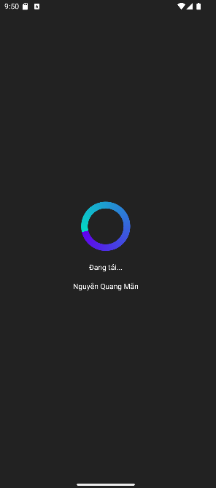
Bài 3
Bai3Activity.java
package com.example.uidesign;
import android.content.Intent;
import android.net.Uri;
import android.os.Bundle;
import android.widget.ImageView;
import androidx.appcompat.app.AppCompatActivity;
public class Bai3Activity extends AppCompatActivity {
@Override
protected void onCreate(Bundle savedInstanceState) {
super.onCreate(savedInstanceState);
setContentView(R.layout.activity_bai3);
ImageView callIcon = findViewById(R.id.call_icon);
callIcon.setOnClickListener(v -> {
Intent intent = new Intent(Intent.ACTION_DIAL);
intent.setData(Uri.parse("tel:0901234567"));
startActivity(intent);
});
}
}
activity_bai3.xml
<?xml version="1.0" encoding="utf-8"?>
<LinearLayout xmlns:android="http://schemas.android.com/apk/res/android"
xmlns:app="http://schemas.android.com/apk/res-auto"
xmlns:tools="http://schemas.android.com/tools"
android:layout_width="match_parent"
android:layout_height="match_parent"
android:orientation="vertical"
android:background="@color/gray_light"
tools:context=".Bai3Activity">
<!-- ẢNH ĐẠI DIỆN VÀ TÊN -->
<FrameLayout
android:layout_width="match_parent"
android:layout_height="350dp">
<ImageView
android:layout_width="match_parent"
android:layout_height="300dp"
android:scaleType="centerCrop"
android:src="@drawable/img"
tools:ignore="ContentDescription" />
<TextView
android:layout_width="wrap_content"
android:layout_height="wrap_content"
android:layout_gravity="bottom"
android:layout_marginStart="70dp"
android:layout_marginBottom="90dp"
android:fontFamily="sans-serif"
android:text="@string/txt_name"
android:textColor="@color/black"
android:textSize="40sp" />
<!-- ICON GỌI ĐIỆN NỔI -->
<ImageView
android:layout_width="80dp"
android:layout_height="80dp"
android:layout_gravity="end|bottom"
android:layout_marginEnd="20dp"
android:layout_marginBottom="10dp"
android:background="@drawable/bg_oval"
android:padding="20dp"
android:src="@drawable/img_2"
app:tint="@color/white"/>
</FrameLayout>
<!-- DANH SÁCH THÔNG TIN LIÊN HỆ -->
<TableRow
android:layout_width="match_parent"
android:layout_height="wrap_content"
android:padding="20dp">
<ImageView
android:id="@+id/call_icon"
android:layout_width="60dp"
android:layout_height="60dp"
android:padding="10dp"
android:src="@drawable/img_3"
app:tint="@color/indigo"
tools:ignore="ContentDescription"
android:contentDescription="Call"/>
<LinearLayout
android:layout_width="match_parent"
android:layout_height="wrap_content"
android:layout_marginStart="30dp"
android:orientation="vertical">
<TextView
android:layout_width="match_parent"
android:layout_height="wrap_content"
android:text="@string/txt_phone1"
android:textColor="@color/gray_dark"
android:textSize="20sp" />
<TextView
android:layout_width="match_parent"
android:layout_height="wrap_content"
android:layout_marginTop="5dp"
android:text="@string/txt_title_mobile"
android:textColor="@color/gray_mid"
android:textSize="18sp" />
<TextView
android:layout_width="match_parent"
android:layout_height="wrap_content"
android:layout_marginTop="30dp"
android:text="@string/txt_phone2"
android:textColor="@color/gray_dark"
android:textSize="20sp" />
<TextView
android:layout_width="match_parent"
android:layout_height="wrap_content"
android:layout_marginTop="5dp"
android:text="@string/txt_title_mobile"
android:textColor="@color/gray_mid"
android:textSize="18sp" />
<View
android:layout_width="match_parent"
android:layout_height="0.5dp"
android:layout_marginTop="30dp"
android:background="@color/gray_mid" />
</LinearLayout>
</TableRow>
<TableRow
android:layout_width="match_parent"
android:layout_height="wrap_content"
android:padding="20dp">
<ImageView
android:layout_width="60dp"
android:layout_height="60dp"
android:padding="10dp"
android:src="@drawable/img_4"
app:tint="@color/indigo"
tools:ignore="ContentDescription" />
<LinearLayout
android:layout_width="match_parent"
android:layout_height="match_parent"
android:layout_marginStart="30dp"
android:orientation="vertical">
<TextView
android:layout_width="match_parent"
android:layout_height="wrap_content"
android:text="@string/txt_email"
android:textColor="@color/gray_dark"
android:textSize="20sp" />
<TextView
android:layout_width="match_parent"
android:layout_height="wrap_content"
android:layout_marginTop="5dp"
android:text="@string/txt_title_mobile"
android:textColor="@color/gray_mid"
android:textSize="18sp" />
</LinearLayout>
</TableRow>
</LinearLayout>
Colors.xml
<?xml version="1.0" encoding="utf-8"?>
<resources>
<color name="purple_200">#FFBB86FC</color>
<color name="purple_500">#FF6200EE</color>
<color name="purple_700">#FF03DAC5</color>
<color name="teal_200">#FF03DAC5</color>
<color name="teal_500">#FF03DAC5</color>
<color name="black">#FF000000</color>
<color name="white">#FFFFFFFF</color>
<color name="green">#FF00FF00</color>
<color name="gray_mid">#979797</color>
<color name="gray_dark">#535353</color>
<color name="indigo">#424FB7</color>
<color name="gray_light">#FAFAFA</color>
</resources>
Strings.xml
<resources>
<string name="app_name">Animal Sound</string>
<string name="txt_name">Nguyễn Quang Mẫn</string>
<string name="txt_phone1">0901234567</string>
<string name="txt_title_mobile">Mobile</string>
<string name="txt_phone2">092834982982</string>
<string name="txt_email">aliconnors@example.com</string>
</resources>
Kết quả
